Task 9: KPI Dashboard and Business Performance Analysis

Dashboard Analysis
The KPI dashboard provides an overview of CoreTech Innovation's business performance. The company has 50 clients and generated approximately 298K in total revenue. Data Analytics is the top performing service, while LinkedIn is the most effective lead source. The average client rating of 4.29 shows positive customer satisfaction. The dashboard also highlights the need to reduce pending projects and improve payment collection.
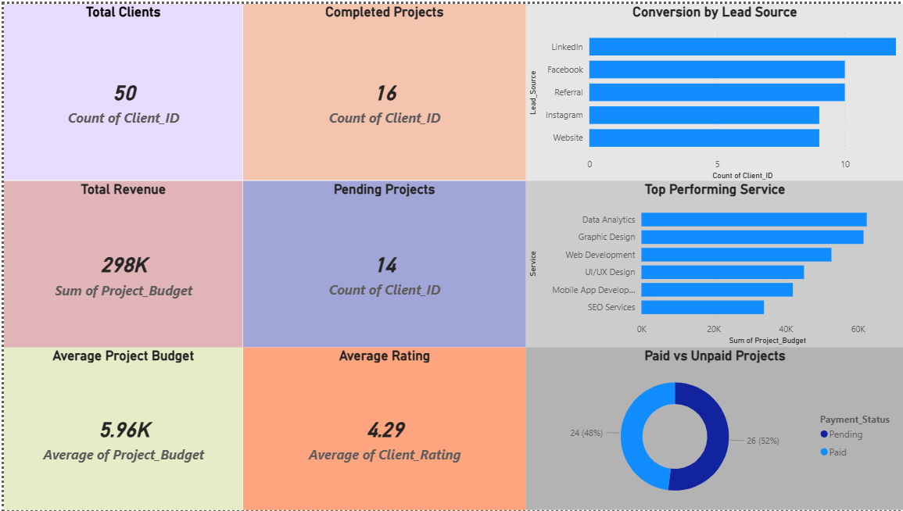

Business Questions
- Highest Revenue Service:
The highest revenue generating service is Data Analytics. It has the largest project budget among all services.
- Best Lead Source:
LinkedIn is the best lead source because it brings the highest number of clients.
- Most Clients City:
The city with the highest number of clients can be identified from the Clients by City chart in the dashboard.
- Areas Needing Improvement:
The company should focus on reducing pending projects and improving payment collection for unpaid projects.

5 Insights
- CoreTech has a total of 50 clients.
- The total revenue generated from projects is approximately 298K.
- Data Analytics is the top performing service with the highest revenue contribution.
- LinkedIn is the most effective lead source for attracting clients.
- The average client rating is 4.29, which indicates good customer satisfaction.

3 Recommendations
- Invest more resources in Data Analytics services as it generates the highest revenue.
- Increase marketing efforts on LinkedIn to attract more potential clients.
- Improve project management and payment follow-up processes to reduce pending projects and unpaid payments.

